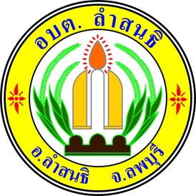

The Lam Sonthi Subdistrict Administrative Organization No Gift Policy commitment :
” lntegrous and Transparent Ministry of lnterior 2026” and “Refrain from Accepting
Or Offering” Any Gifts of Any Kind Related to Official Duties.(No Gift Policy)
.......................................................
Ms. Praphaporn Klararot, Head of the Secretariat, Acting Secretariat of Lam Sonthi Subdistrict Administrative Organization, performing the duties of the Chief of Lam Sonthi Subdistrict Administrative Organization. Hereby declare that Lopburi province shall be and organization of which all authorities refrain from accepting or requesting any gifts and benefits related to official dutes. I also declare my intention to lead Lopburi province personnel in their commitment to upholding the Pillars of the Kinfdom:Nation. Religions. Monarchy. And a democratic regime of government whit the King ad Head of State. I shall motivate them to abide by the moral and ethical principles of food citizenship. Moreover0. I shall mptivate them to stan for what is right. to put public interest before their own. to do their task in time and responsively. to serve the people wholeheartedly. And humbly. And finally. to administrate work with good governance. Integrity. Transparency. And accountability. In this regard. All Lopburi province personnel shall conduct themselves as follows.
1. "Neither shall engage in persuading, offering, nor accepting bribes, gifts, or any form of reward in relation to official duties."
2. Refrain from allowing or colluding with family members in offering or accepting bribes. gifts. or all forms of rewards from any person involved in official duties.
3. Perform all duties solely for the best interest and mage of the government: avoid and action deemed as conflict of personal and public interests.
4. Minimize the offering and acceptance of property or other benefrts given in good faith, in accordance with the criteria prescribed by the Office of the National Anti-Corruption Commission.
5. Uphold a zero-tolerance stance against the act of offering or accepting, gifts, or all forms of rewards related to official duties. Which may lead to corruption and misconduct.
Please be informed and take action accordingly.
Announced on 29 December, 2026
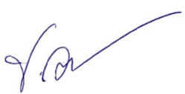

(Ms. Praphaporn Klararot)
Head of the Secretariat,
Acting Secretariat of Lam Sonthi Subdistrict Administrative Organization

